* 1. **ARCHITECTURAL DESIGN**
     1. **INFORMATION SYSTEM ARCHITECTURE**

**INPUT**

**(Data)**

* Customer Information
* Order Information
* Customized Design
* Payment Information
* Delivery Details of Raw Materials

**OUTPUT**

**(Reports/Output)**

* Official Receipt
* Billing Receipt
* Delivery Receipt
* Job Order Form
* Order Report
* Sales Report
* Inventory Report
* Production Report

**PROCESS**

**(Operation)**

* Monitor Inventory
* Manage Orders
* Monitor Production
* Monitor Delivery
* Process Payment
* Manage Collections
* Generate Reports

DATABASE

**(Furniture Shop Management System**)

***Figure 13. Information System Architecture***

* + 1. **WEB ARCHITECTURE**

OWNER/MANAGER, CUSTOMER

BROWSER (Google Chrome, Mozilla Firefox, Microsoft Edge, Mobile Browser)

ORDER MANAGEMENT, BILLING AND COLLECTIONS, PRODUCTION TRACKING SYSTEM

DATABASE

(FURNITURE SHOP MANAGEMENT SYSTEM)

***Figure 14. Web Architecture***

The system will be accessible to the owner/manager of the Furniture Shop and the customers through the browsers as mentioned, Google Chrome, Mozilla Firefox, Microsoft Edge and mobile browsers. It’s processes includes order management, billing and collections and production tracking. All the records gathered through this transactions will be saved in the database.

* + 1. **CLIENT/SERVER ARCHITECTURE**

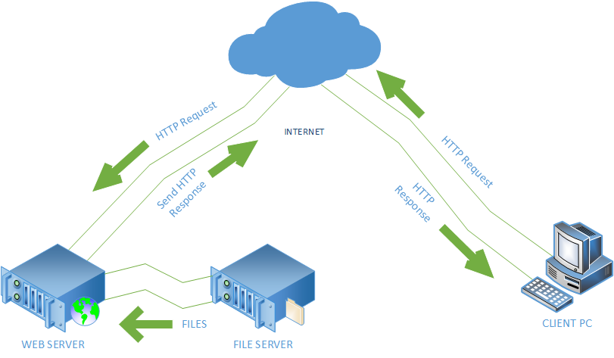

***Figure 15. Client/Server Architecture***

The File Server will store the files needed for the system. Web Server serves as the middle man wherein it processes requests via HTTP and distribute information on the internet. This informations will be displayed as web pages to for the clients to interact.

* + 1. **NETWORK ARCHITECTURE**

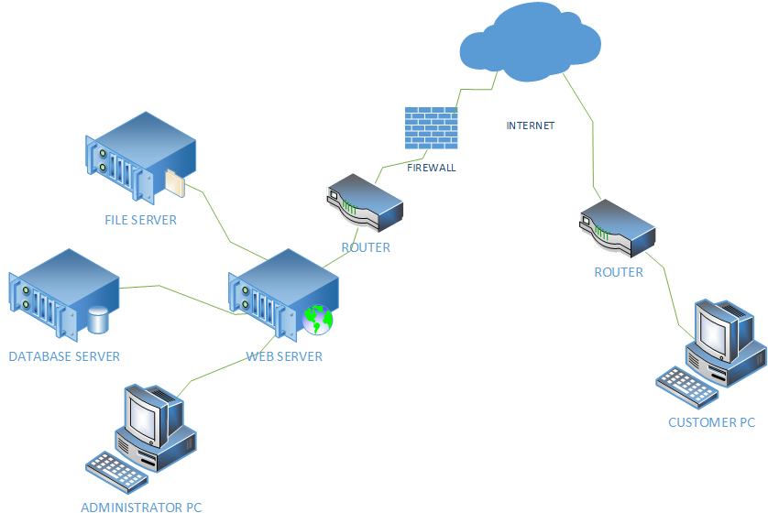

***Figure 16. Network Architecture***

Having a Web Application requires a quality network performance that will ensure the security of data and information of the project. Smooth transaction process will also be experienced. The diagram shows that the firewall will secure the safety of the server and avoid malwares. The files and database used in this system will come from the file server and database server and send to the web server, which serves the customer the web pages they will interact.

**CHAPTER 4**

**IMPLEMENTATION PLAN**

**4.1 TESTING PLAN**

After analyzing the developed system, to be able to detect the defects before deployment and implementation, the proponents choose to conduct four types of testing. It includes the following;

* **Unit Testing**

Under the unit testing, testing of modules and components are done by the programmers themselves. The programmers validated the modules that they made.

* **System Testing**

The system testing, the entire system should be tested as per the requirement and must cover all the parts of the system. A person other than the programmers tested the system to identify other errors and bugs.

* **Security Testing**

The security testing, security is vital when it comes to e-commerce websites because it stores sensitive customer information that's why we require to conduct a security testing.

**4.2. REQUIREMENTS PLAN**

**4.2.1 HARDWARE REQUIREMENTS**

**4.2.1.1 SERVER**

|  |  |
| --- | --- |
| **Hardware Component** | **Specification** |
| Processor | 4 GHz, Intel Core i7 |
| Installed Memory (RAM) | 8.00GB or higher |
| Network | 5Mbps |
| Hard Disk Drive | 1TB or higher |
| Operating System | Windows 7 or higher |

* + - 1. **WORKSTATION**

|  |  |
| --- | --- |
| **COMPONENT** | **SPECIFICATION** |
| Operating System | Windows 7 or higher |
| Web Browser | Google Chrome, Mozilla Firefox, Microsoft Edge, Mobile Browser |

**4.2.2 SOFTWARE REQUIREMENTS**

|  |  |
| --- | --- |
| **COMPONENT** | **SPECIFICATION** |
| Language | PHP 7, HTML 5, CSS 3 |
| Browser | Google Chrome, Mozilla Firefox, Microsoft Edge, Mobile Browser |

* + - 1. **OPERATING SYSTEMS**

|  |  |
| --- | --- |
| **COMPONENT** | **SPECIFICATION** |
| Operating System | Windows 7 or higher |

* + - 1. **DBMS**

|  |  |
| --- | --- |
| **COMPONENT** | **SPECIFICATION** |
| Database | MySQL |

* + 1. **PEOPLEWARE (End Users, Systems Administration, Etc)**

|  |  |
| --- | --- |
| **ACTOR** | **RESPONSIBILITIES** |
| Furniture Shop Owner/Manager | Administrator of the Furniture Shop Management System. Head of the Furniture Shop. Manages transactions of the system. |
| Customer | Orders a furniture, can be from the brochures or sent customize design. Monitors production and delivery of his/her purchased order. |

* 1. **QUALITY PLAN**

To ensure the system is of top quality and can provide the needs of the bussiness, the proponents attests that the system have followed the requirements of the client. It is aligned with the performance, accuracy, reliability and acceptability that will satisfy the requisites of the system.

* The system undergone series of test in order to ensure it is running smoothly.
* People other than the proponents tried using the system to ensure the user friendliness of the system.
* Faster processing of business transactions.
* Valid and reliable outputs/documents.
* The system meets with the functionality and delivers expected results.
  1. **SECURITY PLAN**

|  |  |
| --- | --- |
| **SECURITY POLICIES** | **SECURITY FEATURES** |
| * User Policies | Users allowed to access the system will only be the owner/manager and any user that has confirmed his registration through the email confirmation feature. |
| * Password Policies | Restriction of access of records for files containing confidential informations. The system secures restriction of access from authenticated users only. |
| * Internet Policies | The website has a feature of CAPTCHA that  prevents bot from registering on the website. |

* 1. **SYSTEM MAINTENANCE AND SUPPORT PLAN**

**4.5.1 PREVENTIVE MEASURE PLAN**

In order to attain a smooth transaction process of the system and avoid unnecessary errors, the proponents have acquired preventive measure plan that will help the users of the system, these are the following:

* Critical data and vital records should be backed up and sent off-site for storage.
* A necessarily proper training is conducted.
* The work areas are comfortable and safe.
* Back up files every night, to multiple locations.
* Install anti-virus, anti-malware and a firewall software.
* Do not click suspicious ads or emails.
* Read and apply instruction from the User Manual.
  + 1. **CORRECTIVE MEASURE PLAN**

On the assumption of errors and failures, there are corrective measure to be executed upon the circumstances:

* Scan for viruses with the malware software installed on your PC.
* Retrieve files from the synced data from the trusted host server.
* Contact a professional regarding the failure of the hard drive.

**4.5.3. BACKUP AND RECOVERY PLAN**

To secure the files and functionality of the system, it must have a backup plan. The proponents think of the following as backup and recovery plan:

* **Virus/Malware**

In case of an attack of a malware, the system has installed anti-virus software that will avoid the virus to spread.

* **File Corruption**

To secure files from the system, the proponents determine to have File Server Backup Software installed. To keep files from the transactions made in the system.

* **Database Backup**

Nightly back up of database is stored in the system files. Furthermore, it is also being back up in the Database Server.

**CHAPTER 5**

**RECOMMENDATION**

Upon determining and evaluating every problems encountered by the business, the proponents affirm that the Furniture Shop Management System will be effective in helping the furniture shop from its tedious business process of managing orders and monitoring its production and delivery operation.

The system will be able to lessen the excessive use of papers, and the voluminous brochures. Charts of fabric are organizely stored in the system, wherein the customers can choose from the list of it. It also uses the proper forms needed for every transaction made that will decrease the possible rate of losing a data.

With the Furniture Shop Management System, the shop will have increase in sales because of the reachable way of ordering, through the website. Monitoring of the production and delivery will be easier for both the customer and the management. Queries and Reports will be automatically generated wherein they can track the progress of the business.